

**SEMESTER TWO EXAM 2016**

**ANSWER BOOKLET**

**NAME:**

**FORM:** **DATE:**

|  |  |  |  |  |  |
| --- | --- | --- | --- | --- | --- |
| **Multiple**  **Choice** |  | **Short Answer** |  |  | **Total** |
|  |  |  |  |  |  |
| **20** |  | **47** |  |  | **67** |

|  |  |  |  |  |
| --- | --- | --- | --- | --- |
| 1 | a | XXX | c | d |
| 2 | a | b | c | XXX |
| 3 | a | XXX | c | d |
| 4 | a | b | c | XXX |
| 5 | XXX | b | c | d |
| 6 | XXX | b | c | d |
| 7 | a | b | XXX | d |
| 8 | XXX | b | c | d |
| 9 | a | b | c | XXX |
| 10 | a | b | c | XXX |

**SECTION ONE:** Multiple choice answers

|  |  |  |  |  |
| --- | --- | --- | --- | --- |
| 11 | a | b | XXX | d |
| 12 | a | b | c | XXX |
| 13 | a | XXX | c | d |
| 14 | XXX | b | c | d |
| 15 | a | b | c | XXX |
| 16 | a | b | c | XXX |
| 17 | a | b | XXX | d |
| 18 | a | XXX | c | d |
| 19 | a | b | c | XXX |
| 20 | XXX | b | c | d |

**SECTION TWO: Short Answer (46 marks)**

Answer the questions in the spaces provided.

**Question 21 (4 marks)**

Ethane (C2H6) reacts with oxygen gas (O2) to form carbon dioxide (CO­2) and water vapour (H2O).

**a)** **Identify** the reactants of this reaction.

**Reactants = ethane + oxygen gas – 1 MARK** ___________________________________________________________________________

**b)** **Identify** the products of this reaction.

**Products = carbon dioxide + water vapour – 1 MARK** ___________________________________________________________________________

**c)** **Construct** a word equation for this reaction.

**ethane + oxygen → carbon dioxide + water vapour – 1 MARK**

___________________________________________________________________________

**d)** **Construct** an unbalanced formula equation for this reaction.

**C2H6 + O2 → CO2 + H2O – 1 MARK** _________________________________________________________________

**Question 22 (4 marks)**

Magnesium burns in oxygen gas to form magnesium oxide. Its unbalanced formula equation is: Mg + O2 → MgO

**a)** **Use** this equation to **identify** the chemical formula for magnesium oxide.

**MgO – 1 MARK** ___________________________________________________________________

**b)** **Construct** a word equation describing this reaction.

**Magnesium + oxygen gas → magnesium oxide – 1 MARK** _________________________________________________________________________

**c)** **Identify** which element (Mg or O) is unbalanced in the above equation.

**O is unbalanced– 1 MARK** _____________________________________________________________________

**d)** **Balance** the above equation.

**2Mg + O2 → 2MgO – 1 MARK**

**Question 23 (4 marks)**

**Classify** each of the following reactions as combustion, corrosion, acid/metal, neutralisation, or acid/carbonate reactions:

2HCl + Mg → MgCl2 + H2 acid/metal – (1 mark)

C6H12O6 + 6O2 → 6CO2 + 6H2O combustion – (1 mark)

2HCl + CaCO3 → CaCl2 + H2O + CO2 acid/carbonate – (1 mark)

H2SO4 + 2NaOH → Na2SO4 +2H2O neutralisation – (1 mark)

**Question 24 (4 marks)**

**Balance** the following chemical equations:

**2**

**2**

**3**

1. 

**2**

1. 

**2**

**2**

**6**

**3**

1. 

**4**

**7**

**2**

**6**

1. 

**Question 25 (4 marks)**

Two things can happen to an iron/steel shipwreck when it settles on the ocean floor. It can stay on the floor OR it can sink into the mud. If it stays on the ocean floor, it will rust. If covered by mud, it is sometimes preserved without any rusting.

The rusting of iron is shown in the equation:

4Fe + 3O2 + 2H2O → 2Fe2O3.H2O

**a)** **Use** this equation to **identify** the chemical formula for rust.

**b)** **List** the three reactants needed for rust to form.

**c)** **Propose** a reason why iron might not rust if the shipwreck is covered by mud.

**a** Fe2O3.H2O – (1 mark)

**b** Iron (Fe), oxygen gas (O2) and water (H2O). – (1 mark)

**c**  Mud is wet but sometimes it has no oxygen in it (1 mark). Hence one of the reactants is missing. (1 mark)

**Question 26 (5 marks)**

Use this graph to answer the following questions:

Increasing volumes of sodium hydroxide (NaOH) were added to a solution of hydrochloric acid (HCl). As it was added, the pH changed according to the graph shown below.

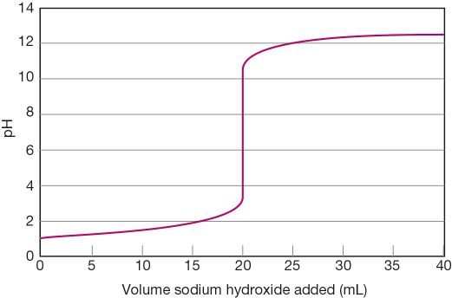

1. State the pH of the solution at the start of the experiment. **1 – 1 MARK**
2. Determine the volume of sodium hydroxide that is needed to be added to exactly neutralise the acid. **20 mL – 1 MARK**
3. Determine the pH when 16 mL of sodium hydroxide was added. **2 – 1 MARK**
4. Determine the total volume of sodium hydroxide added in the experiment. **40 mL – 1 MARK**
5. At the end of the above experiment, what type of solution was formed?

**Basic / alkaline solution – 1 MARK**

**Question 27**

Acids are commonly found around us. Bases can be described as the ‘chemical opposite’ of acids.

1. List the main properties of **acids** and **bases**. (4 marks)
2. What is the difference between a strong and a weak acid? (2 marks)

a) Acids – Any four properties, some examples are given below ( ½ mark each)

1. Have a sour taste
2. Produces a prickling or burning sensation when they come into contact with the skin or they are corrosive
3. They all contain at least one hydrogen atom
4. They tend to react with many metals and releases hydrogen gas and a salt

Bases – Any four properties, some examples are given below ( ½ mark each)

1. They are bitter and feel slippery or soapy to touch
2. They react with fats and oils to produce soaps
3. Some bases can dissolve in water and are called as alkalis
4. They are neutralised by acids producing a salt and water
5. Strong acids are dangerous because they can burn through objects. (1 mark)

Weak acids are much safer as we can eat and drink some of them. (1 mark)

**Question 28 (3 marks)**

**Examine** the food chain shown below.

*water weed → tadpole → moorhen → swamp harrier*

For this food chain, **identify** the:

a producer

**water weed**

b herbivore

**tadpole**

c third order consumer

**swamp harrier**

**Question 29 (2 marks)**

Compare how matter and energy flow through an ecosystem.

1. **Matter recycles – decomposers return the material to the soil and air for reuse by plants.**
2. **Energy does not recycle – it is progressively lost along food chains.**

**Question 30 (2 marks)**

Explain why decomposers are vitally important in a sustainable ecosystem.

**They recycle (1 mark) chemicals/matter between the living and non-living environments. For example, they return chemicals that are needed by producers to the soil.**

**This keeps the ecosystem functioning because it will not run out of resources (1 mark).**

**Question 31 (3 marks)**

**Recall** the following electricity concepts by writing the correct term as described in the adjacent box.

|  |  |
| --- | --- |
| **TERM** | **DESCRIPTION** |
| **Resistance – 1 MARK** | A measure of how difficult it is for the charged particles in an electric circuit to move |
| **Current – 1 MARK** | The flow of electrical charge through a circuit |
| **Voltage – 1 MARK** | The difference in electrical potential energy carried by charged particles at different points in a circuit |

**Question 32 (3 marks)**

Thermos flasks like the one pictured below are designed to keep hot substances hot and cold substances cold. Careful choice of materials and clever design make this possible.

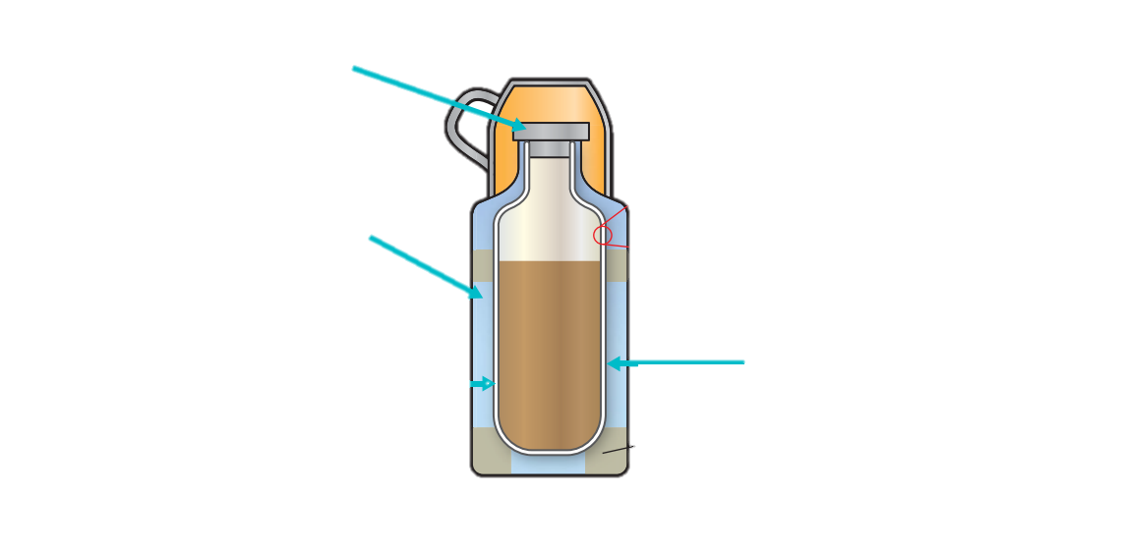

Glass walls: **reflective – ½ mark**

**Directs heat back into flask – ½ mark**

Plastic stopper: **insulator – ½ mark**

**Stops heat from escaping – ½ mark**

Vacuum between the walls: **Layer of air – ½ mark**

**Acts as insulator – ½ mark**

Next to each label in the picture above, **explain** how each choice of material helps to make a thermos flask effective.

**Question 33 (2 marks)**

When two or more globes are connected in a circuit, two different types of connection are possible.

* + 1. **List** two advantages that the parallel circuit will have over the series circuit.
       1. **When extra globes are added in parallel, every globe will glow with the same brightness (OR in series each globe added will be slightly dimmer than the rest) – 1 MARK**
       2. **If one globe “blows” in parallel the other globes will be unaffected (OR if a globe “blows” in series all globes will stop glowing, making it difficult to identify the broken globe) – 1 MARK**

**END OF SHORT ANSWER SECTION**

Continue with extended response on the next page.